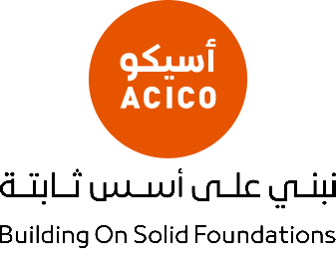

شركة صناعات الخرسانة الخلوية القطرية ذ.م.م
Qatar Aerated Concrete Industries Co. W.L.L

ACICO

Company Profile

Table of Contents

1.1. About Qatar ACICO. 2
1.2. Why Prefer ACICO AAC (Autoclaved Aerated Concrete). 3
1.3. The advantages of using ACICO AAC. 3
1.4. General Information. 5
1.5. Location Map. 6

About Qatar ACICO.
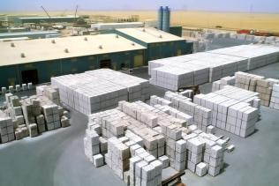
Since the beginning of 1994, Aerated Concrete Industries Co. (ACICO) has been producing AAC (Autoclaved Aerated Concrete) Building materials in Kuwait which is equipped with the most modern production technology with license from HEBEL International, Germany, which has more than 50 years of experience in the production and use of building materials. With more than 45 licensed plants all over the world, the company is a leading producer of building materials. ACICO Plants produce non-reinforced building materials (blocks, Jumbos) in different sizes; reinforced building materials (wall panels, slabs, lintels and stairs); supplementary products (thin bed mortar, plaster and repair mortar).
The building materials are of excellent quality having:
- The best thermal insulation of all solid building materials.
- High acoustical insulation.
- Non-combustible and highly fire resistant properties.
- Economical finishing works (Tiles, Plaster, and Electrical Work etc.).
- Lightweight and can be easily handled.
In the year 2005, ACICO Industries Co., Kuwait formed a Qatar-based conglomerate, for the establishment of ACICO Plant in Qatar. The Plant is envisioned to produce AAC materials of excellent quality for local and foreign markets.
Qatar Aerated Concrete Industries Co. W.L.L. was established on 13th November, 2005 as a joint venture between Nasser Bin Khaled & Sons Holding Co. (51%) and Kuwait based ACICO Industries (49%). The company was established to cope up with the demand for AAC building materials in the construction industry of Qatar, in keeping with the architectural renaissance taking place in the State of Qatar nowadays.
Presently we are producing Autoclaved Aerated Concrete (AAC) both Reinforced Building materials such as Wall Panels, Floor / Roof Slabs, Lintels, Stairs and Non-Reinforced building materials such as lightweight blocks and jumbo blocks of different sizes with the latest technology available today.

Why Prefer ACICO AAC (Autoclaved Aerated Concrete).
Autoclaved Aerated Concrete (AAC) is a lightweight, precast building material. It is formed into blocks and panels for a wide range of load bearing and non-load bearing construction applications. It is a solid, high performance lightweight concrete blocks. AAC is manufactured using basic raw materials such as quartz sand, cement, lime and aluminum paste.
AAC is an environmentally friendly building material and does not generate pollutants or toxic agents that would be harmful to humans and to the environment. It also provides remarkable sound insulation, thermal efficiency, fire resistance, mold, and pest resistance in a single material among other advantages.
In every building that constructed with ACICO structural elements, they ensure a healthy working environment from the standpoint of biology and architectural physics.

The advantages of using ACICO AAC.
 | LIGHTWEIGHT | AAC is lightweight. It can weight as little as one-fifth the weight of standard concrete, which results in lower transportation costs, faster workflow and lower material handling costs. AAC is a “ready to build” material, requiring no on site curing time.
 | EXCELLENT THERMAL INSULATION | AAC has exceptional thermal insulating qualities. Consequently, AAC lowers energy costs for cooling and heating, and makes the use of additional thermal insulation unnecessary.
 | SOUND INSULATION | The solid wall construction of a building made of AAC provides exceptional acoustic insulation. Its porous structure and high surface mass, coupled with its ability to dampen mechanical vibration energy, greatly reduces outside environmental noise pollution and the indoor echo effect in empty rooms, providing a quieter, more comfortable interior for the occupants.
 | MOLD RESISTANT | ACICO AAC is a breathable, concrete product made with clean, inorganic materials and does not offer the nutrients needed for mold growth.
 | PEST RESISTANT | ACICO AAC is an inorganic, insect/pest resistant, solid wall construction material. AAC concrete products cannot be penetrated by termites or insects. So, without concerns of termites and other insects damaging/inhabiting the AAC portion of the structure, chemical treatments can be reduced while maintaining the maximum protection against damage to the building.
 | FIRE RESISTANT | AAC is non-combustible. AAC offers the greatest fire resistance of any building material currently on the market. The use of AAC eliminates the need for applying costly fireproofing materials. Additionally, no toxins or dangerous gasses are emitted when AAC is subjected to extreme heat.
 | DESIGN VERSATILITY & FLEXIBILITY | Unlimited workability. AAC can be sawn, drilled, nailed, screwed and milled with common hand tools. Much like wood, AAC openings are easily and accurately cut. Field adjustments can be made easily. Chases for wiring and outlets can easily be accomplished precisely. The dimensionally accurate panels are finished with a very thin mortar joint, producing surface that requires minimum rendering.
 | LESS TIME AND LABOR COSTS | Fast Installation and quicker customer payback. No furring, insulation, or drywall needed. Panelized AAC products have a dramatic impact on the material’s rate of installation. Wall and floor panels are both easy to use and quickly installed, thus enabling a standard crew to install more than four times the square footage of AAC than that of a regular masonry application in the same period of time.
 | ENVIRONMENTALLY FRIENDLY | AAC is a “Green” building material. The manufacture and use of AAC generates no pollutants or toxic agents. AAC contains all natural ingredients/raw materials from sand, lime, cement, water and expanding agent. Less consumption of fuel, electricity and nominal wastage during production and saves electricity – all these advantages reduces the environment pollution. In fact, wherever AAC is used, energy is saved.
 | DURABILITY | AAC structures are highly durable and will not degrade under normal atmospheric conditions. AAC products have been in use in many countries around the world for over 75 years and across GCC. Since that time the material has proven its durability under many varying climatic and chemical conditions.

General Information.

شركة صناعات الخرسانة الخلوية القطرية ذ.م.م
Qatar Aerated Concrete Industries Co. W.L.L.

Address : Gabro Area, Mesaieed Industrial City
Building No.433, Zone 92, Street 702.
P.O. Box : 32076, Doha-Qatar
Tel No. : +974 4032 4100
Sales Tel. No. : +974 4032 4132
Fax No. : +974 4032 4112
Email : info.qatar@acicogroup.com
Sales Email : sales.qatar@acicogroup.com
Website : www.acicogroup.com

Location Map.
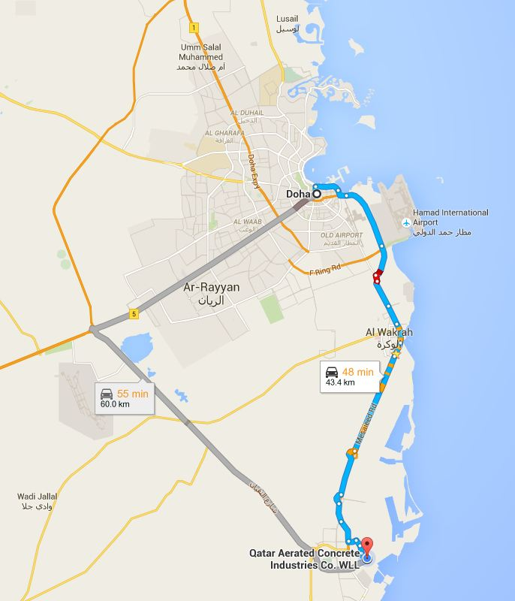

https://goo.gl/maps/4qWSLvThwA92

